SUMMARY REPORT

Dataset Inspection
- Total Rows :1810
- Total Columns : 5
- Missing Timestamps : 223
- Missing Ratings : 439
- Missing Feedback Text : 10
- Rows after removal 1810
- After Dropping Duplicates 1732
- Invalid Dates 130

Hidden Traps
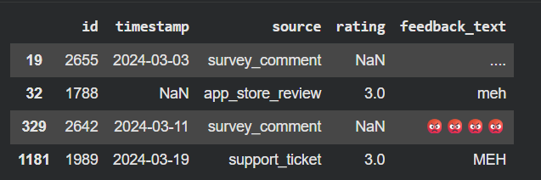

Task: Classify customer feedback, Transform unstructured customer feedback into actionable insights.
API key : Gemini 2.5 Flash
Approach
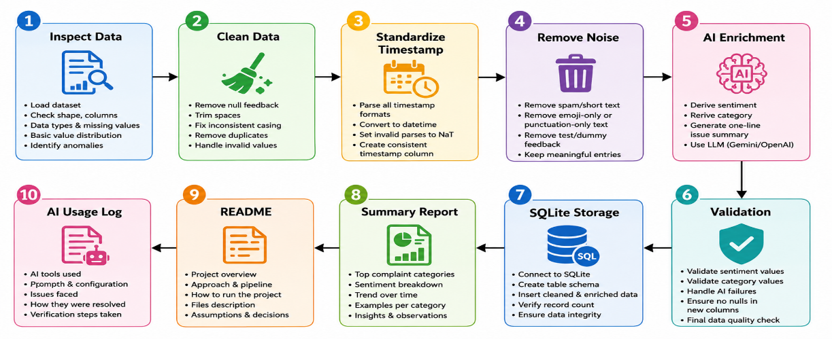
RESULT:
- Total - 1732
- Positive - 204
- Negative - 355
- Neutral - 1173
Trade-offs
- Used GPT for classification.
- Added validation to prevent invalid categories.
- Did not fully cluster semantic duplicates due to time constraints.

AI LOG
Task | AI Usage | Issue Found | Fix Applied
Data Cleaning Strategy | Used ChatGPT to identify cleaning steps for messy feedback data | Some rows contained meaningless text such as "meh", "...." and emoji-only entries | Added noise filtering and minimum text length validation
Timestamp Standardization | Asked AI for handling multiple date formats | Some timestamps could not be parsed | Used pd.to_datetime(errors='coerce') and handled invalid dates
Duplicate Detection | Used AI to suggest duplicate removal methods | Near-duplicate feedback messages were not detected | Applied exact duplicate removal and considered fuzzy matching techniques
Sentiment Classification | Used ChatGPT to design sentiment classification logic | Initial logic missed emoji-based sentiment | Added emoji sentiment detection for positive and negative emojis
Category Classification | Used AI to design keyword mapping rules | Some feedback was categorized incorrectly or returned invalid categories | Restricted output to the five allowed categories and added validation
Issue Summary Generation | Used AI to suggest concise summarization approach | Long messages produced unclear summaries | Generated short issue summaries using truncated and cleaned text
Dashboard Development | Used AI to generate React dashboard components | JSX and chart component errors occurred | Corrected React syntax and fixed Recharts component imports
CSV Processing | Used AI to create file upload and parsing workflow | Some CSV files contained blank rows | Enabled skipEmptyLines and added null checks
Data Visualization | Used AI to design charts and KPIs | Charts lacked labels and readability | Added labels, legends, tooltips, and styled components
Validation & Testing | Used AI to suggest validation checks | Edge cases such as emoji-only feedback were missed | Added custom validation and manual sample verification

OUTPUT:
